St Isan Road Surgery

If you need any support completing these forms please ask our reception teams who will be happy to help you. Please ensure you complete the Purple GMS (General Medical services) form clearly at the front of this leaflet.
You can obtain your NHS number from your previous GP surgery.
We do understand that not all questions on our registration forms are applicable to all patients. However it is important we use the registration process to capture as much information as possible. This is to ensure that we are offering you the best standard of care and can signpost patients who may need extra support at the point of registration. Please complete the registration forms to the best of your knowledge with as much information as possible.

DOB

PATIENT NAME

We recommend that patients provide identification when registering at the practice. If you’re unable to provide identification we can still register you. However you won’t be able to access our online services without proof of identification.
We do recommend patients sign up for online services.
Have you been registered with our GP Practice before? Yes
No
If you have previously been de-registered under our zero-tolerance scheme you must not register with our practice, without first writing to the Practice Manager with your request. If the practice declines your request to register they will inform you in writing of the decision. The practice has a right to remove your registration at their discretion at any time if you have previously been removed from our list for abusive behavior and not informed them at the point of re-registering.

I wish to have access to the following online services (please tick all that apply):
- Booking appointments
- Requesting repeat prescriptions
- Accessing my medical record

Please provide photographic identification and proof of address to register with our online services.

St Isan Road Surgery

TEL No (home): |  | TEL No (work):
TEL No (mobile) |  | EMAIL ADDRESS
Consent for SMS messages  Do you consent to us contacting you by SMS messages?  Yes No |  | Consent for email correspondence  Do you consent to us contacting you by email?  Yes No
NEXT OF KIN:
Name
Address (including postcode) Contact number
Your relationship

Would you like to be provided with an ACP booklet (Advanced Care Planning)? Yes No

Advance Care Planning is a process that enables individuals to make plans about their future health care.
Name & address of Nominated Pharmacy for prescriptions

SUMMARY CARE RECORD

Your records will automatically be coded for an Enhanced Summary Care Record.
If you do not want a summary care record, please ask at reception for an OPT out form and tick here

Your Summary Care Record is a short summary of your GP medical records. It tells other health and care staff who care for you about the medicines you take and your allergies. It means they can give you better care if you need health care away from your usual doctor's surgery: for example, in an emergency, when you're on holiday, when your surgery is closed, at out-patient clinics or when you visit a pharmacy.

THIRD PARTY ACCESS
In the Practice we aim to provide you with the highest quality of healthcare. To do this we must keep records about you, your health and the care we have provided or plan to provide to you. Everyone working for the NHS has a legal duty to keep information about you confidential.
If you would like a family member or carer to have access to your medical records on your behalf. We need to keep their contact details on your records.
The person you nominate must be happy to have their details recorded in your medical records. If you wish to nominate someone for this reason please provide us with their details and sign below that you consent to this

Name of nominated individual …………………………………………………….
Your signature ……………………………………… Date ……………………….

St Isan Road Surgery

First Spoken Language: | English | Other (Please state)  ………………………………….. | Do you require an interpreter? Yes No

Ethnicity: | British | Irish | Other White | Asian or British Asian | Black or British Black
 | Indian | Pakistani | Bangladeshi | Chinese | Other Asian
 | Caribbean | African | Other Black | Mixed | Other

LIFESTYLE
Blood pressure reading (please use pod in reception if available )

HEIGHT: |  |  |  | WEIGHT:
Do you smoke cigarettes? |  | Never / Ex-smoker/ Yes |  |  |  | How many per day?
Do you smoke any of the  following? | Pipe |  | Roll ups |  | Vaping |  | Cannabis

Would you like help to stop smoking? | *Yes | Not at this time
*We will email or post information out to you to help you quit.

PERSONAL MEDICAL HISTORY
(please tick any that are relevant and write the date of diagnosis where possible)

ANGINA/HEART DISEASE | ARTHRITIS | ASTHMA/COPD
CANCER | DIABETES | EPILEPSY
HIGH BLOOD PRESSURE | LEARNING DISABILITIES | OSTEOPOROSIS
MENTAL HEALTH SUPPORT | AF | THYROID DISEASE
STROKE/MINI-STROKE | PREDIABETES | OTHER
Please list medicines taken for the conditions above

St Isan Road Surgery

FAMILY HISTORY

HEART PROBLEMS (i.e. ANGINA/HEART ATTACK) | YES / NO | RELATIONSHIP / AGE:
STROKE (CVA) | YES / NO | RELATIONSHIP / AGE:
CANCER | YES / NO | RELATIONSHIP / AGE:
DIABETES | YES / NO | RELATIONSHIP / AGE:
ASTHMA | YES / NO | RELATIONSHIP / AGE:

MEDICATION

Medication:

If you are taking regular medication from your previous GP please can you provide us with a copy of your medication list. Please allow yourself plenty of time so you do not run out of medication, and bring along any previous prescription requests / medication with you to the appointment. If you need an appointment with a GP or Practice Nurse we will contact you.

Please note we do not accept prescription requests over the phone unless you are housebound, and prescriptions take 48-72 hours to be processed.
List any over the counter medication used regularly

Please advise of any known allergies

St Isan Road Surgery

New Patient Health Check

Would you like to be booked an appointment for a new patient health check with our HCA (Healthcare Assistant)?
No
Yes
I would like to be booked an appointment for a new patient health

VETERANS
Do you or have you served in the armed forces?  What is your service number ………………………………….. | Yes | No

CARERS

Are you a carer for someone else? | Yes | No

Is there someone you rely on for your care? (please circle ) | family | friend | paid carer | social care support

Would you like to be referred to Carers MK? | Yes | No

WOMEN ONLY
( Please √ )

I have had a total hysterectomy and therefore do not require a smear test

TRANSGENDER PATIENTS ONLY

( Please √ )

Do you know if you are eligible for a smear? If you’re not sure, please book a telephone appointment with our practice nurse.
( Please √ )

Have you realigned your gender since birth? If yes please give details, including preferred pronoun?
St Isan Road Surgery

DO YOU DRINK ALCOHOL – Please complete below by circling your answers

FAST | Scoring system |  |  |  |  | Your score
 | 0 | 1 | 2 | 3 | 4
How often have you had 6 or more units if female, or 8 or more if male, on a single occasion in the last year? | Never | Less than monthly | Monthly | Weekly | Daily or almost  daily
Only answer the following questions if the answer above is Never (0), Less than monthly (1) or Monthly (2). Stop here if the answer is Weekly (3) or Daily (4).
How often during the last year have you failed to do what was normally expected from you because of your drinking? | Never | Less than monthly | Monthly | Weekly | Daily or almost  daily
How often during the last year have you been unable to remember what happened the night before because you had been drinking? | Never | Less than monthly | Monthly | Weekly | Daily or almost  daily
Has a relative or friend, doctor or other health worker been concerned about your drinking or suggested that you cut down? | No |  | Yes, but not in the last  year |  | Yes, during the last  year

This is one unit of alcohol…
…and each of these is more than one unit

St Isan Road Surgery

COMMUNICATION

We want to make sure you can read and understand the information we send you. If you find it hard to read letters or if you need someone to support you at appointments, please let us know in the answers given below.

Patients with hearing impairment

Do you lip-read or use a hearing aid or other communication tool? | YES | NO
IF SO, WHICH?

Do you need a British Sign Language interpreter or advocate with longer appointment times? | YES | NO
IF YES, WHICH?

Patients with visual impairment

Do you need information in another format? For example, large print or easy to read? | YES | NO
IF YES, WHICH?

All patients

How would you prefer us to communicate with you? (PLEASE CIRCLE) | LETTER | EMAIL | TEXT | OTHER
IF OTHER, PLEASE STATE WHAT?

Is there any other communication support we should provide for you? | YES | NO
IF YES, PLEASE STATE WHAT?

St Isan Road Surgery

Consent

I consent to the practice contacting me by text message and/or email message for the purposes of health promotion and for appointment reminders.

I acknowledge that appointment reminders by text and/or email are an additional service and that these may not take place on all/or on any occasion and that the responsibility of attending appointments or cancelling them still rests with me. I can cancel the text and/or email message facility at any time.

Text messages are generated using a secure facility however I understand that they are sent over a public network onto a personal telephone and as such may not be secure, however the practice will not transmit any information which would enable an individual patient to be indentified.

I agree to advise the practice if my email address changes and also if my mobile telephone number changes or if this is no longer in my possession.

The practice does not share mobile phone contact details or email addresses with any external non-NHS organisation.

Your medical records may be used for financial or clinical audit, post payment verification checks, medical research or education purposes.

Date

Signature

I confirm that the information given above is accurate to the best of my knowledge and that I live within the practice boundary catchment area as detailed in this pack and I confirm that I have read and understood the Contract of care provided in this pack

Date

Signature

St Isan Road Surgery

Have you had or are you at risk of having falls? | Yes | No
Do you use a walking aid? | Yes | No
If yes please can you state what aid you use?

We have a wealth of information on our website about falls prevention and community organisations that can help, but if you have any specific concerns please speak to our reception team.

St Isan Road Surgery

You can only register at our practice if you live within the catchment area for our practice. Please only submit your registration if you live within the areas below – IF you have completed this form and do not live in our boundary area you can take this form to any surgery in Milton Keynes close to your home address

Practice Boundary area map

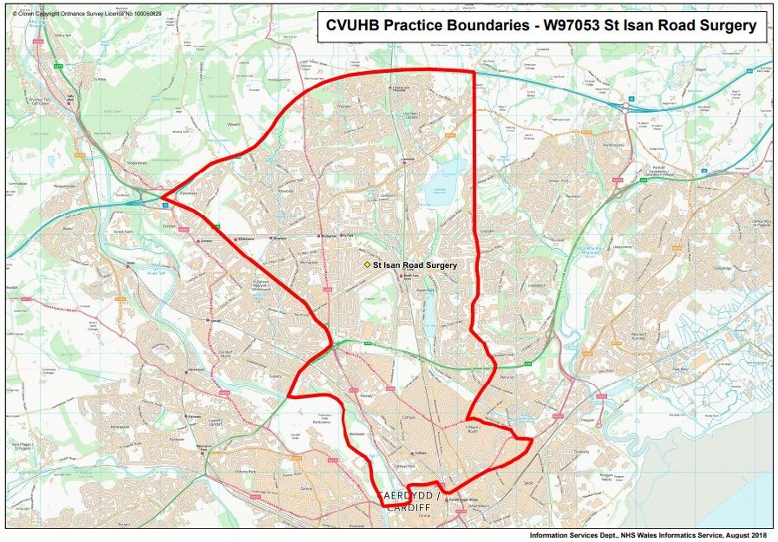
St Isan Road Surgery

Contract of Care

The GPs, Nurses, Practitioners and Staff aim to provide the highest possible care to our patients. The aim of this Contract of Care is to ensure that you understand the practice policies and why such policies are in place, and then follow them. We particularly recommend that you read closely the details relating to our Appointment, Repeat Prescribing and Behaviour expectations.

Your responsibilities: | Practice responsibilities:
Comply with recommended treatment. | Offer access to quality medical services.
Participate in appropriate screening and prevention programmes. | Provide you with an appointment with a GP or appropriate healthcare professional or signpost you to a suitable alternative service in line with our appointments procedure.
Commit to a healthy lifestyle with support from the Practice if required. | Enable you to access relevant appointments with the right clinician the first time.
Treat clinicians and staff with dignity and respect at all times. | Treat you with dignity and respect at all times.
Be aware of our practice booking system and use this appropriately to book with the appropriate clinician. | Ensure all patients have access to a patient information leaflet which includes information on how to book an appointment.

Information about all the services we provide are detailed on our website www.stisanroadsurgery.co.uk If you do not have access to the internet, please ask at reception for a practice leaflet. Before deciding that you wish to join the Practice we ask that you review this information in order to decide whether you can follow the policies presented by the Practice in line with the General Medical Services GP contract.

